https://amberbluegalleries.com/publications/
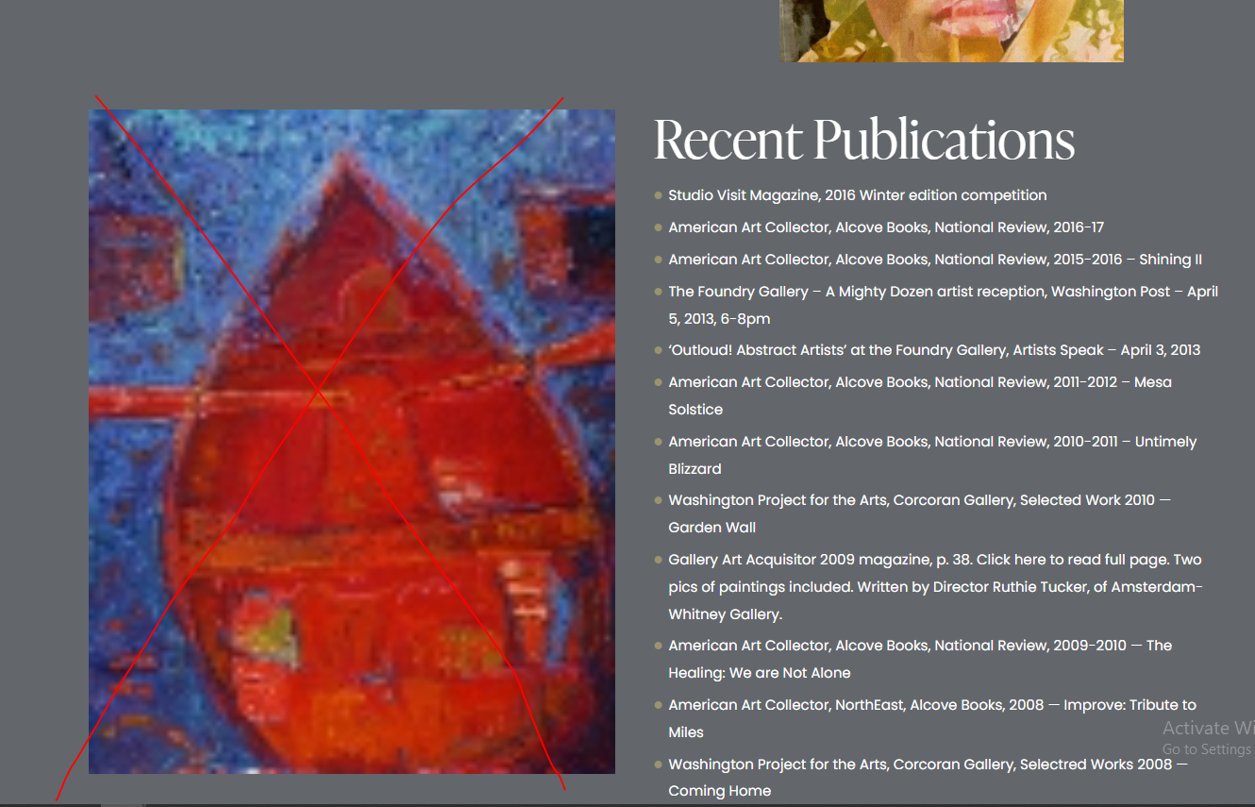

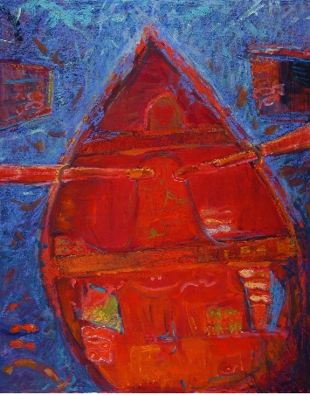
Ye image yahan se hata den aur iski jaga ye wala laga den. Please make sure k pixel na tootay aur iska title hoga “ Little Soul Boat”. (See below url for reference)

http://amberblue.org/CDs041607/CD8/e1.htm

https://amberbluegalleries.com/publications/
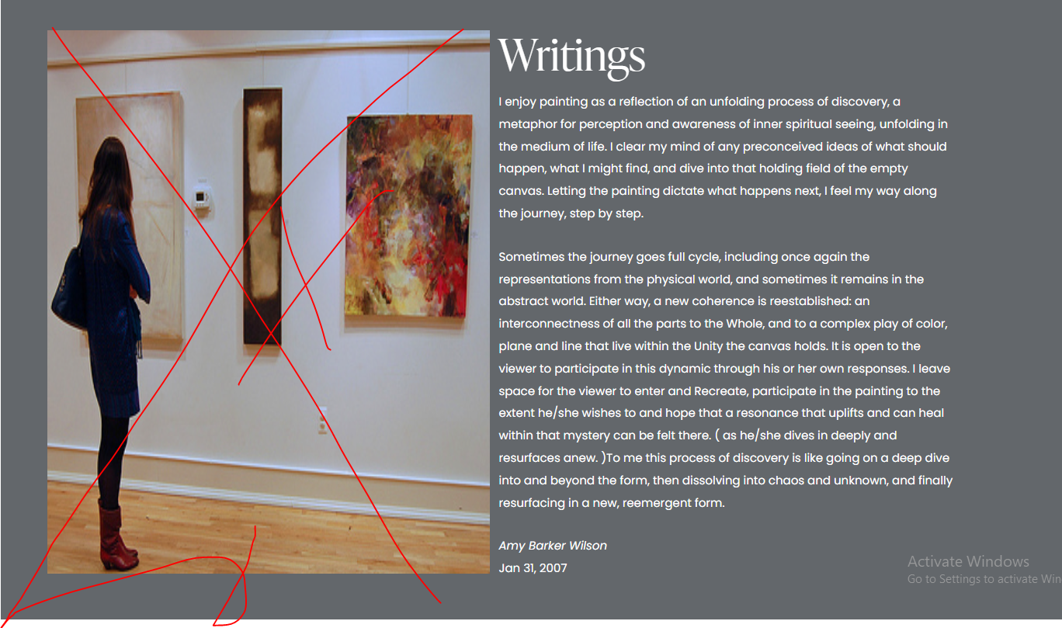

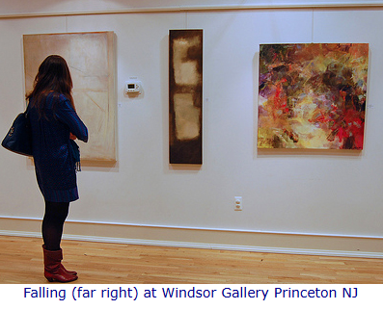
Ye image yahan se hata den aur iski jaga ye wala laga den. Please make sure k pixel na tootay aur iska title hoga “ Little Soul Boat”. (See below url for reference)

http://amberblue.org/Writings.htm

